CS 305 Project One

Document Revision History

Version | Date | Author | Comments
1.0 | 19 October 2026 | Richard Clark

Client



Instructions
Submit this completed vulnerability assessment report. Replace the bracketed text with the relevant information. In this report, identify your security vulnerability findings and recommend the next steps to remedy the issues you have found.

- Respond to the five steps outlined below and include your findings.
- Respond using your own words. You may also include images or supporting materials. If you include them, make certain to insert them in the relevant locations in the document.
- Refer to the Project One Guidelines and Rubric for more detailed instructions about each section of the template.

Developer

Richard Clark

1. Interpreting Client Needs
Determine your client’s needs and potential threats and attacks associated with the company’s application and software security requirements. Consider the following questions regarding how companies protect against external threats based on the scenario information:

- What is the value of secure communications to the company?
- Are there any international transactions that the company produces?
- Are there governmental restrictions on secure communications to consider?
- What external threats might be present now and in the immediate future?
- What modernization requirements must be considered, such as the role of open-source libraries and evolving web application technologies?

Secure communications are essential for Artemis Financial because the company deals with sensitive information such as personal identification information, financial account details, investment and retirement data, and insurance information. It also ensures integrity of the company along with regulatory compliance and customer trust.
It is not specifically mentioned that Artemis Financial operates outside the United States with international transactions, but considering the company creates financial plans involving investments, retirement, and insurance, it’s possible their clients could have accounts or assets that connect to international institutions. For security planning, it’s safest to treat their communications as potentially global. This means that strong encryption and secure API communication are essential.
Because Artemis Financial works with retirement, investment, savings, and insurance data, there are several U.S. laws that apply. The Gramm-Leach-Bliley Act requires financial institutions that offer consumers financial products and services to explain their information-sharing practices to their customers and to safeguard sensitive data (Federal Trade Commission, n.d.). California’s CCPA/CPRA privacy law explains that California residents have rights over their personal information, including the right to know what data is being collected, the right to delete it, and the right to opt out of its sale. It also requires businesses to protect personal data and to be transparent about how they use and share consumer information (California Department of Justice, n.d.). The FCICyber page also explains that both SEC and FINRA require financial firms to protect customer information and maintain secure systems. Their cybersecurity guidance includes expectations for strong encryption, secure transmission of data, and protection of investment-related information from unauthorized access (FCI Cybersecurity, n.d.). These are but a few of the many laws that surround restrictions on secure communications that pertain to Artemis Financial.
Artemis Financial faces several external threats. The project’s current dependencies include outdated and vulnerable components. Spring Boot 2.2.4 and BouncyCastle 1.46 are both outdated and present immediate external threats because attackers can exploit these vulnerabilities to intercept communications, compromise data integrity, or gain unauthorized access to Artemis Financial’s REST API. Iron-Clad Java and Oracle’s secure-coding guidelines explain that web applications are commonly attacked through injection, cross-site scripting, cross-site request forgery, session hijacking, man-in-the-middle attacks, and unsafe deserialization (Manico & Detlefsen, 2014; Oracle, 2025). The Spring REST guides add that unsecured endpoints, weak authentication, and exposing sensitive data are frequent risks in REST-based systems (Spring, 2026). CVE.org and the NVD show that attackers regularly exploit known vulnerabilities in outdated libraries, which matters for Artemis Financial because its current dependencies fall into versions with documented CVEs (CVE.org, n.d.; NVD, n.d.).
Artemis Financial needs to modernize its system by keeping its open-source libraries up to date and adapting to newer web technologies. Because the application relies on older components like Spring Boot 2.2.4 and BouncyCastle 1.46, it inherits known vulnerabilities that attackers can exploit (CVE.org, n.d.; NVD, n.d.). Modern applications depend heavily on open-source libraries, and financial systems need to keep up with current security and technology standards. Adopting stronger encryption, updating REST patterns, and following modern secure-coding practices are all part of keeping the application aligned with today’s standards for protecting sensitive financial data.

2. Areas of Security
Refer to the vulnerability assessment process flow diagram. Identify which areas of security apply to Artemis Financial’s software application. Justify your reasoning for why each area is relevant to the software application.

The web application takes data through its web forms and REST API. This requires strong input validation to avoid problems like injection, cross-site scripting, or unsafe deserialization. Any time user-provided data enters the system, there’s a risk that an attacker could try to send something unexpected or harmful. Strong input validation helps make sure the data is safe before the application uses it. This includes checking that values are in the right format, rejecting anything suspicious, and making sure JSON payloads match what the API expects.
Artemis Financial relies on a REST API to deliver its financial services, which makes the security of its API a major part of the assessment. The API is the main way clients and systems interact with the application, so it must be designed and protected carefully. This includes making sure every endpoint requires proper authentication and authorization, validating all incoming data, and preventing attackers from accessing information they shouldn’t. Secure API interactions also involve using HTTPS, avoiding the exposure of sensitive details in URLs or error messages, and making sure the API responds safely when something goes wrong. Because the API handles financial data, any weaknesses like an unprotected endpoint, poor validation, or outdated libraries, could lead to unauthorized access or data leaks.
Cryptography is a major part of Artemis Financial’s security because the application handles sensitive financial information that must be always protected. Strong encryption is needed both when data is stored and when it moves across the network, especially since financial data is a high-value target for attackers. If the application relies on older cryptographic components, like outdated versions of BouncyCastle, it may be exposed to weaknesses that attackers can exploit to break encryption, intercept communications, or tamper with data
Artemis Financial uses a traditional client/server setup, where the client sends requests and the server processes them and returns responses. The server handles financial data, user input, and API calls, so it must be designed to handle requests safely and consistently. That includes making sure communication happens over HTTPS, that the server doesn’t trust client-side behavior, and that the server enforces all validation, authentication, and authorization rules. Secure distributed composing is about how different parts of the system work together and pass data between them. Artemis Financial has multiple internal layers that include controllers, services, data access components, and the REST API. Each layer receives data, processes it, and passes it along, which means every step needs to be secure.
Artemis Financial’s application is built with Java and Spring Boot. Secure coding practices help prevent common mistakes that can turn into vulnerabilities, such as improper input handling, unsafe object creation, or relying on outdated libraries. Code quality also matters because clear, well-structured code is easier to maintain, easier to review, and less likely to hide bugs that attackers could exploit.
Code error handling is another important part of this area. When something goes wrong, the application needs to fail safely. That means catching exceptions properly, avoiding detailed error messages that reveal internal system information, and logging issues in a secure way. Poor error handling can accidentally expose sensitive data or give attackers clues about how the system works.

3. Manual Review
Continue working through the vulnerability assessment process flow diagram. Identify all vulnerabilities in the code base by manually inspecting the code.

The project uses BouncyCastle version 1.46, which is old and has known security issues. Relying on outdated cryptography is risky because this library helps protect sensitive financial data. The project also uses Spring Boot version 2.2.4.RELEASE, which is old and no longer supported. Older versions can contain security problems because they depend on outdated libraries and don’t receive new fixes or patches. When the framework isn’t kept up to date, the whole application becomes more vulnerable and harder to maintain. Updating BouncyCastle and Spring Boot to a current version is important.
In the DocData class, the database connection is created using a URL, username, and password that are written directly into the code, which is a major security concern. Hard-coding credentials like "jdbc:mysql://localhost:3306/test", "root", "root" allows anyone who opens this file can immediately see the database login information. One secure way to handle database credentials is to move them out of the code and into environment variables. Instead of writing the username and password directly in Java, you set them in the system, then reference them in application.properties so the code never sees the actual values.
In the CRUDController class, the /read endpoint accepts a business_name parameter from the user, but the code never checks whether that input is safe, valid, or even in the correct format. When a controller accepts user input without validation, it opens the door to several risks, including injection attacks, broken logic, unexpected errors, and misuse of the endpoint. A secure approach is to check that the value isn’t empty, enforce a length limit, and allow only safe characters. Spring Boot also supports built-in validation annotations, which helps make it easier to enforce rules directly on the request parameter.
In the myDateTime class, the methods that are supposed to handle time values don’t do anything meaningful. The retrieveDateTime() method returns a brand-new int[3] array every time it’s called, but it never includes the actual hour, minute, or second stored in the object. Any code that tries to read the time will always get an empty array instead of real values. The setter method, setMyDateTime, is also unimplemented, so there is no way to safely update the time fields. There is also no validation, so other classes can modify them directly with invalid or unexpected values.
The customer class stores an account number and balance, lets other classes read the account number, and allows deposits by adding the given amount to the balance. However, it doesn’t validate input, doesn’t protect the balance, and doesn’t enforce any financial rules. The deposit(int a) method simply adds the amount to the balance without checking whether the value is valid. It allows negative deposits, which could be used to withdraw money through the deposit function, and it doesn’t protect against integer overflow, which can cause the balance to wrap around to an incorrect value.

In the GreetingController class, the /greeting endpoint accepts a name parameter from the user and immediately inserts it into a formatted string using String.format. The controller doesn’t verify whether the name value is empty, enforce a length limit, or contains unexpected characters.
In both the customer class and the myDateTime class, several fields are not marked as private, which means any other class in the same package can modify them directly. Fields like account_balance, mySecond, myMinute, and myHour are exposed without any protection or control. Other parts of the application can change values in unpredictable ways, bypassing validation, business rules, or safety checks. For financial data such as account_balance, this is especially dangerous because it allows unauthorized or accidental changes that can corrupt account information. This is an encapsulation problem.

4. Static Testing
Run a dependency check on Artemis Financial’s software application to identify all security vulnerabilities in the code. Record the output from the dependency-check report. Include the following items:

- The names or vulnerability codes of the known vulnerabilities
- A brief description and recommended solutions provided by the dependency-check report
- Any attribution that documents how this vulnerability has been identified or documented previously

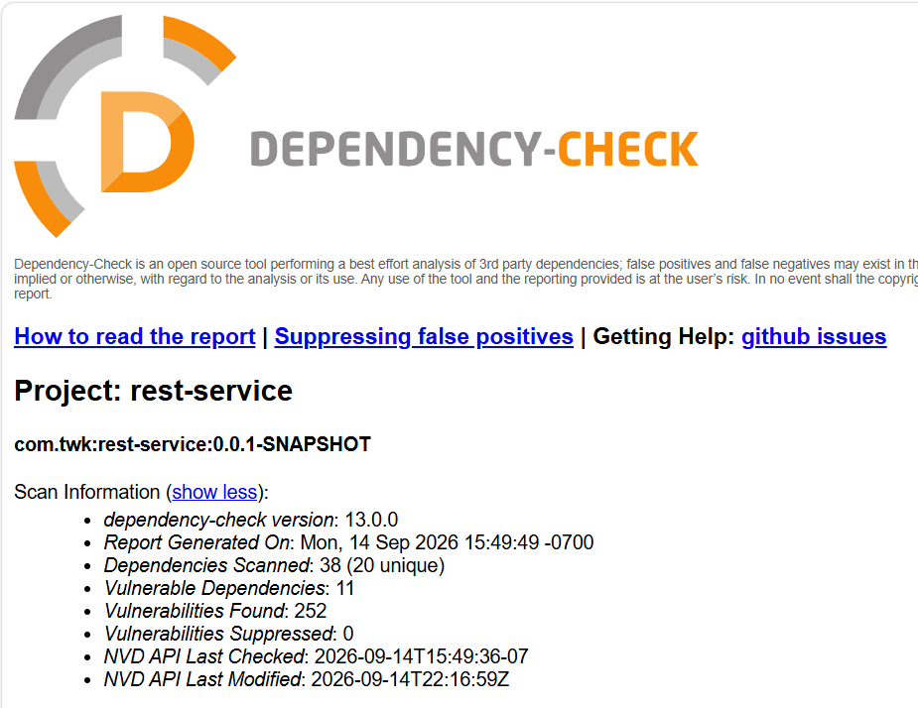

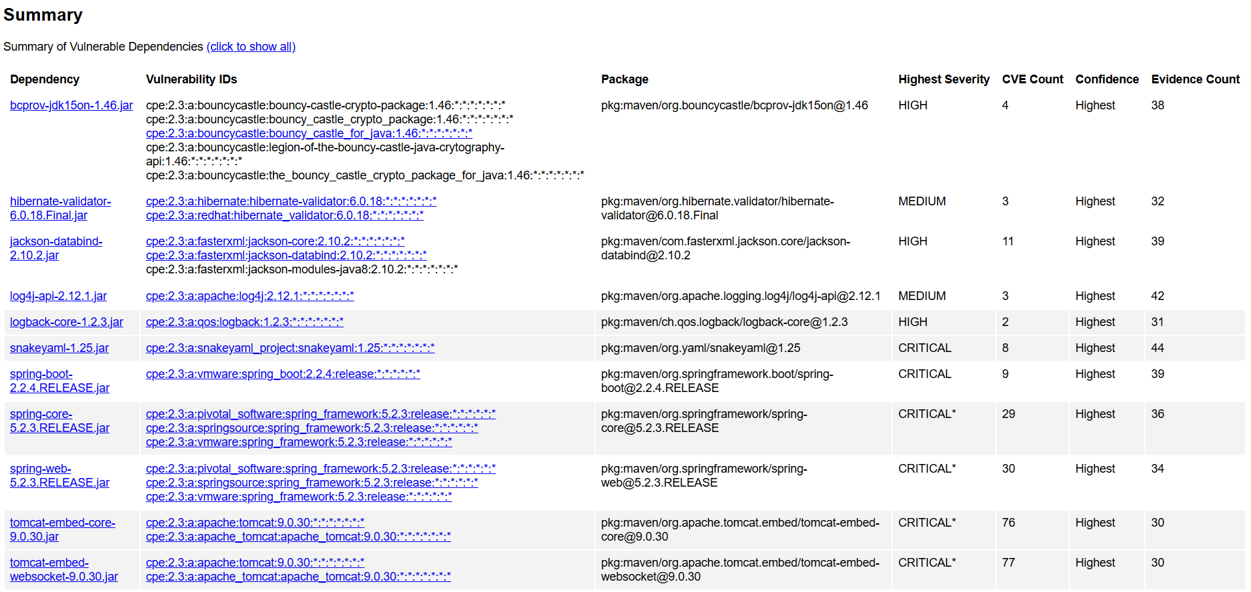

Dependency | Dependency
bcprov-jdk15on-1.46.jar | hibernate-validator-6.0.18.Final.jar
CVE: 4 total  CVE-2016-1000338 - improper cryptographic implementation  CVE-2020-15522 - incorrect bcrypt validation  CVE-2023-33202 - flawed ECDSA signature verification  CVE-2015-7940 - improper X.509 certificate parsing | CVE: 3 total  CVE-2025-35036 – unsafe expression interpolation  CVE-2023-1932 – HTML sanitization bypass  CVE-2020-10693 – improper input validation
NVD Description:  BouncyCastle bcprov-jdk15on-1.46 contains vulnerabilities involving outdated and improperly implemented cryptographic functions that can lead to weakened encryption, information disclosure, or incorrect cryptographic output. These flaws allow attackers to exploit weaknesses in key handling or algorithm behavior, potentially exposing sensitive financial data or reducing the effectiveness of security controls. Updating to a patched BouncyCastle version (1.70 or later) is recommended to mitigate all known vulnerabilities. | NVD Description:  Hibernate Validator 6.0.18.Final contains vulnerabilities involving unsafe expression interpolation, improper HTML sanitization, and flawed input validation. These issues may allow attackers to inject unexpected expressions, bypass validation rules, or introduce malicious content into validation messages. Updating to Hibernate Validator version 6.2.x or later is recommended to mitigate all known vulnerabilities.

Dependency | Dependency
jackson-databind-2.10.2.jar | log4j-api-2.12.1.jar
CVE: 11 total  CVE-2020-36518 – unsafe deserialization  CVE-2019-12384 – remote code execution  CVE-2020-36179 – polymorphic type handling flaw  CVE-2020-36180 – unsafe class instantiation  CVE-2020-36181 – deserialization bypass  CVE-2020-36182 – improper input validation  CVE-2020-36183 – unsafe type resolution  CVE-2020-36184 – deserialization vulnerability  CVE-2020-36185 – remote code execution risk  CVE-2020-36186 – improper type restriction  CVE-2020-36187 – unsafe deserialization | CVE: 3 total  CVE-2026-34479 – unsafe deserialization  CVE-2026-34477 – remote code execution risk  CVE-2020-9488 – improper input validation
NVD Description:  Jackson Databind 2.10.2 contains multiple vulnerabilities involving unsafe deserialization, improper type handling, and flawed input validation. These issues allow attackers to craft malicious JSON payloads that may trigger remote code execution, instantiate unexpected classes, or bypass type-safety restrictions during object mapping. Updating to Jackson Databind version 2.15.x or later is recommended to mitigate all known vulnerabilities. | NVD Description:  Log4j-api 2.12.1 contains vulnerabilities involving unsafe deserialization, improper input validation, and potential remote code execution. These flaws allow attackers to manipulate serialized input or logging data in ways that may lead to unauthorized actions or system compromise. Updating to a patched Log4j version (2.17.x or later) is recommended to mitigate all known vulnerabilities.

Dependency | Dependency
logback-core-1.2.3.jar | snakeyaml-1.25.jar
CVE: 2 total  CVE-2023-6378 – unsafe deserialization  CVE-2021-42550 – improper input validation | CVE: 8 total  CVE-2022-1471 – unsafe deserialization  CVE-2017-18640 – remote code execution risk  CVE-2022-25857 – improper input validation  CVE-2022-38749 – unsafe class loading  CVE-2022-38751 – deserialization vulnerability  CVE-2022-38752 – remote code execution risk  CVE-2022-41854 – improper input handling  CVE-2022-38750 – unsafe deserialization
NVD Description:  Logback core 1.2.3 contains vulnerabilities involving unsafe deserialization and improper input validation. These issues allow attackers to influence logging behavior or introduce malicious data into the logging pipeline. Updating to Logback version 1.4.x or later is recommended to mitigate all known vulnerabilities. | NVD Description:  SnakeYAML 1.25 contains vulnerabilities involving unsafe deserialization, improper input validation, and unsafe class loading. These issues allow attackers to craft malicious YAML payloads that may trigger remote code execution, load unexpected classes, or manipulate application behavior during YAML parsing. Updating to SnakeYAML version 1.33 or later is recommended to mitigate all known vulnerabilities.

Dependency | Dependency
spring-boot-2.2.4.RELEASE.jar | spring-core-5.2.3.RELEASE.jar
CVE: 9 total  CVE-2020-5398 – improper input validation  CVE-2020-5421 – unsafe expression parsing  CVE-2021-22060 – authentication bypass risk  CVE-2021-22096 – insecure configuration handling  CVE-2022-22965 – remote code execution  CVE-2022-22950 – denial-of-service via SpEL  CVE-2022-22946 – improper request handling  CVE-2022-22947 – remote code execution via routing  CVE-2022-22963 – function invocation injection | CVE: 29 total  Group Summary:  - Expression parsing vulnerabilities – unsafe SpEL evaluation  - Remote code execution risks – exploitable core processing flaws  - Improper input validation – insufficient sanitization and filtering  - Denial-of-service issues – expression and routing-related DoS vectors  - Insecure configuration handling – unsafe bean and resource processing  - Authorization and type-handling flaws – bypass and unsafe class loading
NVD Description:  Spring Boot 2.2.4.RELEASE contains multiple vulnerabilities involving improper input validation, unsafe expression parsing, insecure configuration handling, and remote code execution risks. These issues may allow attackers to exploit weaknesses in request processing, expression evaluation, or routing logic, potentially leading to unauthorized access, denial-of-service, or full system compromise. Updating to Spring Boot version 2.7.x or 3.x is recommended to mitigate all known vulnerabilities. | NVD Description:  Spring Core 5.2.3.RELEASE contains multiple vulnerabilities involving unsafe expression evaluation, improper input validation, insecure configuration handling, and remote code execution risks. These grouped issues allow attackers to exploit weaknesses in Spring’s core processing pipeline, including SpEL parsing, bean handling, and request mapping. Successful exploitation may lead to denial-of-service, unauthorized access, or full system compromise. Updating to Spring Framework version 5.3.x or later is recommended to mitigate all known vulnerabilities.

Dependency | Dependency
spring-web-5.2.3.RELEASE.jar | tomcat-embed-core-9.0.30.jar
CVE: 30 total  Group Summary:  - Remote code execution vulnerabilities – exploitable request-handling flaws  - Unsafe deserialization issues – insecure processing of HTTP payloads  - Improper URL and path validation – traversal and routing weaknesses  - HTTP request smuggling flaws – incorrect header and request parsing  - Expression injection vulnerabilities – unsafe SpEL evaluation in web contexts  - Information disclosure risks – exposure of internal routing or error details | CVE: 76 total  Group Summary:  - Authentication and authorization bypass vulnerabilities – improper enforcement of security constraints  - Session fixation and session persistence flaws – unsafe session handling  - HTTP/2 denial-of-service issues – resource exhaustion through malformed requests  - Request smuggling and header injection vulnerabilities – incorrect parsing of HTTP headers  - Information disclosure risks – exposure of internal server details  - Input validation and URL-rewriting flaws – unsafe request routing and improper validation
NVD Description:  Spring Web 5.2.3.RELEASE contains multiple vulnerabilities involving unsafe deserialization, improper URL and path validation, insecure request parsing, and remote code execution risks. These issues allow attackers to craft malicious HTTP requests that may bypass validation, manipulate routing, inject harmful expressions, or trigger unauthorized code execution within the web layer. Updating to Spring Framework version 5.3.x or later is recommended to mitigate all known vulnerabilities. | NVD Description:  Tomcat-embed-core 9.0.30 contains numerous vulnerabilities involving authentication bypass, session fixation, HTTP/2 denial-of-service, request smuggling, and improper input validation. These issues allow attackers to manipulate HTTP requests, exhaust server resources, bypass access controls, or expose sensitive information through flawed request processing. Updating to Tomcat version 9.0.83 or later is recommended to mitigate all known vulnerabilities.version (2.12.x or later) is required to mitigate all known vulnerabilities.

Dependency

tomcat-embed-websocket-9.0.30.jar

CVE: 77 total

Group Summary:

- Authentication and access-control bypass issues – improper enforcement of security constraints
- WebSocket session handling flaws – unsafe persistence and incorrect session validation
- HTTP/2 denial-of-service vulnerabilities – resource exhaustion through malformed frames
- URL-rewriting and routing weaknesses – improper request mapping and validation
- Information disclosure issues – exposure of internal headers or server details
- Input validation flaws – unsafe processing of WebSocket and HTTP data

NVD Description:

Tomcat-embed-websocket 9.0.30 contains numerous vulnerabilities involving authentication bypass, improper WebSocket session handling, HTTP/2 denial-of-service, and flawed request routing. These issues allow attackers to manipulate WebSocket or HTTP traffic, bypass access controls, exhaust server resources, or expose sensitive information through incorrect request processing. Updating to Tomcat version 9.0.83 or later is recommended to mitigate all known vulnerabilities.

5. Mitigation Plan
Interpret the results from the manual review and static testing report. Then identify the steps to mitigate the identified security vulnerabilities for Artemis Financial’s software application.

The results of both the manual review and the static testing report show that the application contains several security weaknesses. There are outdated libraries, unsafe deserialization practices, improper input validation, insecure configuration defaults, and weak cryptographic handling. It is recommended to upgrade all vulnerable dependencies, such as Spring Core, Spring Web, Spring Boot, Tomcat, Jackson Databind, SnakeYAML, Log4j, Hibernate Validator, and BouncyCastle, to their latest secure versions.
Input validation needs to be strengthened across the entire project. The controller classes CRUDcontroller.java and GreetingController.java should validate all incoming request parameters because they receive user input directly from HTTP endpoints. The classes customer.java, CRUD.java, Greeting.java, and myDateTime.java should enforce basic validation rules so objects cannot be created with unsafe or invalid values. The DocData.java class must carefully check and sanitize any external information it reads or processes. The RestServiceApplication.java should also apply global validation rules and enable filters that stop unsafe requests early, preventing harmful input from reaching the controllers.
Cryptographic improvements should be made in RestServiceApplication.java, since this class is responsible for starting and configuring the entire application. It should define secure encryption settings, enforce proper certificate validation, remove insecure cryptographic defaults, and register secure providers. Because this class controls the app’s global behavior, it is also the correct place to disable debug endpoints and apply CORS restrictions.
Safer HTTP handling should be added to the controllers. CRUDcontroller.java and GreetingController.java need to validate headers, check routing parameters, and reject invalid or oversized input before processing it. At the application level, RestServiceApplication.java should set up filters that limit how large a request can be, add basic checks for all incoming requests, and stop anything suspicious before it ever reaches the controllers.

Resources

California Department of Justice. (n.d.). California Consumer Privacy Act (CCPA). Retrieved September 15, 2026, from https://www.oag.ca.gov/privacy/ccpa

CVE Program. (n.d.). CVE® List. https://www.cve.org/

FCI Cybersecurity. (n.d.). SEC & FINRA cybersecurity requirements. Retrieved September 15, 2026, from https://fcicyber.com/resources/sec-finra-cybersecurity

Federal Trade Commission. (n.d.). Gramm–Leach–Bliley Act (GLBA). Retrieved September 15, 2026, from https://fcicyber.com/resources/sec-finra-cybersecurity
Manico, J., & Detlefsen, A. (2014). Iron-Clad Java: Building Secure Web Applications. McGraw Hill Computing.

National Institute of Standards and Technology. (n.d.). National Vulnerability Database: Vulnerability search. https://nvd.nist.gov/vuln/search?resultType=records
Oracle. (2025). Secure Coding Guidelines for Java SE. https://www.oracle.com/java/technologies/javase/seccodeguide.html

Spring. (2026). Building REST services with Spring. https://spring.io/guides/tutorials/rest

Spring. (2026). Spring Quickstart Guide. https://spring.io/quickstart

Southern New Hampshire University. (2026). CS 305 Vulnerability Assessment Process Flow Diagram [PDF]. https://learn.snhu.edu/content/enforced/2377304-CS-305-12569.202681-1/course_documents/CS%20305%20Vulnerability%20Assessment%20Process%20Flow%20Diagram.pdf

